Fenham Hall Medical Group
Newsletter - Summer 2023
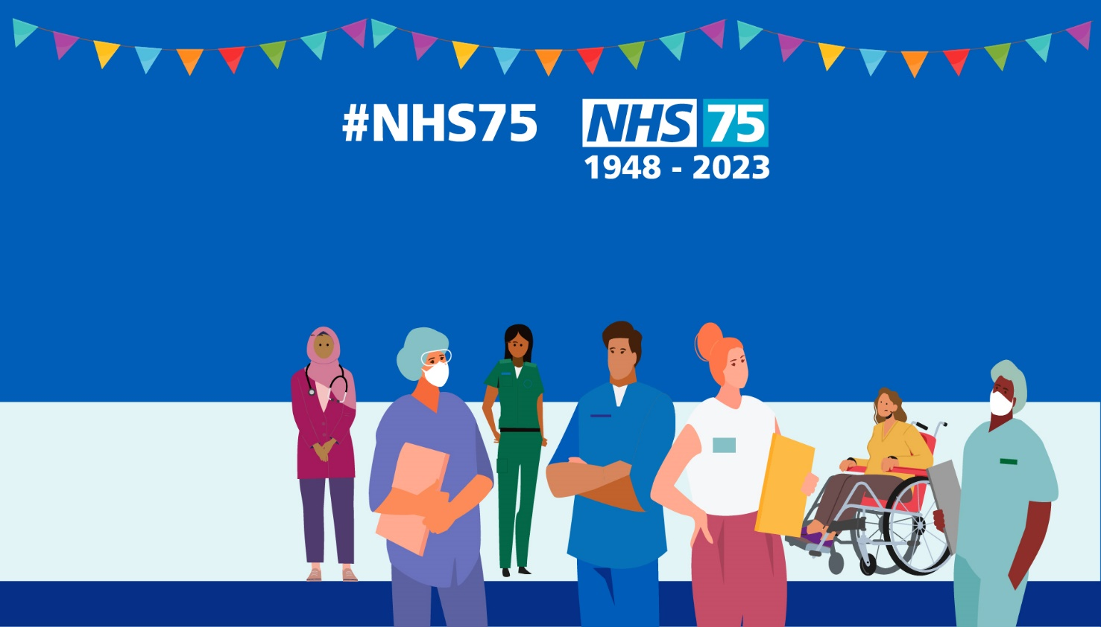

A Word from Dr McTernan
Welcome to the Fenham Hall Medical Group newsletter! We are delighted to share news about the practice with you and hope that you find this newsletter to be interesting and informative!
Our Patient Participation Group is looking to recruit as many new members as possible into our Virtual Patient Participation Group, so if would be interested in volunteering your time, please find further information on page 8.
We have been doing a lot of work on updating our website, so please have a look at this for answers to common questions and information about common health conditions.
For up-to-date information on our practice and more, please follow us on Twitter and Facebook.
Happy reading!
Dr Catherine McTernan
GP Partner
Chair of the Patient Participation Group

Surgery Opening Hours
We are open, Monday to Friday, from 8:30am to 6pm, apart from bank holidays when we are closed all day, and some afternoons when we are closed for staff training. You can find these dates on the website here, and listed below.
We offer extended hours sessions on a Monday and Thursday morning, from 7am until 8am (for pre-booked appointments only - we are unable to assist with any other queries during these times).
We are closed on a Saturday.
You can book an appointment during our Saturday Extended Access Hub at Elswick Family Practice for things like blood taking, height and weight checks, annual health review checks and baby immunisations (please contact us to book an appointment).
We are closed on a Sunday.
To improve our service to you, the surgery doors will be open from 8.20am on Monday, Wednesday and Friday mornings.
Routine morning surgeries will continue to run from 8.30am.

Staff Training Dates
We will be closed on the following dates and times:
Monday 28th August ALL DAY (bank holiday)
Wednesday 20th September 12pm to 6pm
Tuesday 17th October 12pm to 6pm
Tuesday 14th November 12pm to 6pm
Monday 25th December ALL DAY (bank holiday)
Tuesday 26th December ALL DAY (bank holiday)
When we are closed, if you require medical advice, you should dial 111, visit 111, or visit a Walk In Centre.
If you have a medical emergency, you should dial 999 or attend A&E as soon as possible.

Patient Feedback
We want you to get a great service from us, and to have easier access to the surgery. We welcome your comments and thoughts on this.
If you feel that a member of staff has gone beyond your expectations to provide excellent care or service, please contact Helen Gunn, Practice Manager and Managing Partner, as we have a staff recognition scheme, or pop a review on NHS Choices
Likewise, if you feel we could have done something better, we still want to hear from you. Please don’t do this anonymously via NHS Choices as we cannot change or improve if we don’t have specific details. We can assure you that your concerns will be listened to, and we will do our best to learn from your experiences.
You can also tell us what you think by completing a Friends and Family test, which can be found on our website. Answering the questions will help us to know if we are doing a good job, or if we could do things better!

Dignity at work
Our practice team are dedicated and hard-working professionals, committed to providing a high standard of care to our patients.
Our aim is to be polite and helpful to all patients.
Please treat all our team with the same respect.
Aggressive and rude behaviour will not be tolerated and may result in you being asked to register with another practice.
There is never an excuse for abuse.
Helen Gunn
Practice Manager

Recycling Your Inhalers
A friendly reminder that you should take all used inhalers to local pharmacies to be recycled. Inhalers should not be disposed of in your household waste. You can also take all blister packs (weekly medication packs) to Superdrug stores to be recycled.
RETURN YOUR USED INHALERS TO A PHARMACY TO HELP REDUCE YOUR CARBON FOOTPRINT
The propellants used in some inhalers are powerful greenhouse gases that contribute to climate change. Even after an inhaler is finished it still contains these environmentally damaging gases.
(Please be assured these gases are not harmful to you when you use your inhaler)
Return all used inhalers to your local pharmacy for safe disposal – returned inhalers will be incinerated which will destroy the greenhouse gases and prevent inhaler plastics going to landfill.
Don't throw used inhalers into your household waste of recycling bins! Landfill disposal of inhalers is harmful to the environment due to left over gases being released into the atmosphere. Plastics from inhalers cannot be recycled using domestic recycling schemes.

Make each puff count! Only order your inhaler when required, to reduce waste.

If you have concerns about the environmental impact of your inhaler, make an appointment with your GP practice – don't stop using your inhaler!

Waiting Times
The current waiting time for a routine GP appointment at the practice is two weeks. We have 8 GPs working at the practice and are offering more appointments than ever before; we are simply seeing an unprecedented increase in demand.
When you call us for an appointment, you may be offered an appointment to see a clinician other than a GP such as a nurse or first contact physiotherapist, either at our practice or local Walk in Centres. We would like to encourage you to attend these alternative clinics, as this allows the practice to reduce waiting times and means that you receive quicker treatment. We are so grateful for your patience, co-operation, support and understanding, both for us at the practice and our other patients.
We may also offer you certain kinds of appointments at our Saturday clinic at Elswick Family Practice, NE4 6SH. This is known as our Enhanced Access Hub, and you can book into this for childhood immunisations, bloods, FeNO testing, annual health reviews and more. Please ask us for more details!

Registrar training
Dr McTernan was a GP trainer at her previous surgery and has gone through the necessary steps at Fenham Hall Medical Group to renew this qualification. We are a training practice and from August 2023 will begin to host registrars. Registrars are fully qualified doctors from various specialities who are training to become GPs.
Dr Dave Ryan is an Anaesthetist who is now in training to become a GP. He is our first registrar and has been here with us since the 1st of August!
Changes to appointments
New NHS England guidance around appointments has been published. This means that we will be changing our current appointment system to offer appointments two weeks in advance. We also offer 3-day ahead appointments, GP same day appointments and urgent same-day appointments.
We will always deal with genuinely urgent cases quickly as possible.
Please let reception know if you are requesting a same-day appointment.
Our receptionists are guided by the GPs to signpost you to the most appropriate service for your medical need. This means that we may advise you to pop into a pharmacy or attend a Walk in Centre for "minor ailment"-type issues. We are grateful for your understanding, as this allows our GPs to deal with the people who really need to see them and can't be seen by another local service.
You can visit our website or ask our reception team for more information.

Changes to the practice
We are very limited on space within our practice and so plans have been made to maximise the space that we have. We are in the process of converting what is currently the reception office into another clinical room so more patients can be seen and receive care.
We have converted two upstairs offices into consulting rooms, so please let us know when you book an appointment if you have any access requirements and if an upstairs appointment would not be suitable.
We are also in the process of having automatic door openers installed on the main entry and foyer doors. This work is planned for the 20th of September.

Tyneside Integrated Musculoskeletal Service (TIMS)
This service offers self-care and fast access to information, resources and expert opinion about a variety of back, neck, joint or general muscle conditions.
Any patient aged 16 years or older and registered with a GP in Newcastle can self-refer for local NHS physiotherapy and other musculoskeletal and pain services, without the need for a GP appointment.
Visit the website, check out their Escape Pain Programme or contact the support team on 0191 4452643.

Online Services
You can use the NHS App or Patient Access to get online. This will allow you to:
- Book, view and amend booked appointments (you can also see hospital appointments on the NHS App).
- See your medical record.
- Update your personal or contact information.
- Order repeat prescriptions (please note, unless prior agreed we cannot accept prescription requests over the phone or via e-mail. This decision has been made to improve patient safety).
Please ask us to provide your online access details so that you can link your account to us. You can request this in-person, via e-mail or via a form on the website.
We offer appointments that can be booked via the NHS App or Patient Access. Where possible please book online to free up the phone lines for people who are unable to get online.
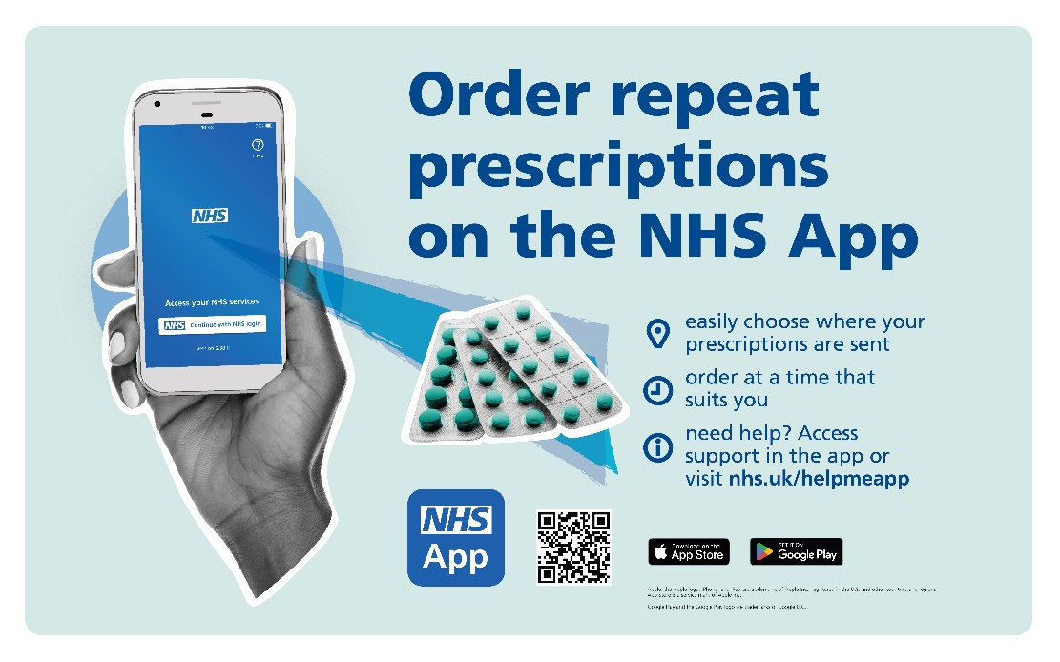
(Image text: order repeat prescriptions on the NHS app. Easily choose where your prescriptions are sent, order at a time that suits you. Need help? Access support in the app or visit nhs.uk/helpmeapp)

Flu Season

Flu season is rapidly approaching! We are hosting a flu vaccination session on Saturday the 23rd of September. We will contact you to offer an appointment if you are eligible.
If you cannot leave your home, we will arrange to visit you at home to give you your vaccine.
Flu Myth:
Getting the flu is not a big deal.

Flu Fact:
The flu can result in serious illness and even death. Some high-risk groups include seniors and infants.

Flu Myth:
The flu vaccine will give you the flu.

Flu Fact:
Flu vaccines cannot give you the flu. Instead, they use an "inactive virus" that helps your immune system fight potential infections.

Flu Myth:
You can't spread the flu if you're feeling well.
Flu Fact:
Actually, 20% to 30% of people carrying the influenza virus have no symptoms.

Flu Myth:
The flu is the same thing as a cold.

Flu Fact:
The flu and cold can have similar symptoms. Contact your doctor if you have any flu symptoms for further testing and treatment.

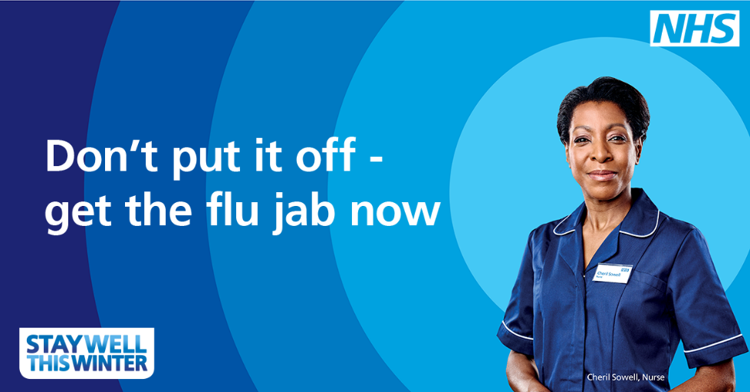
(Image text: Don't put if off – get the flu jab now. Stay well this winter)

Think "Pharmacy First"
Did you know that you can visit your local pharmacy with NO APPOINTMENT NEEDED if you are suffering with a minor illness? Pharmacists can give you advice and, if needed, medication. A few examples of conditions that they can see are:
Back pain, headaches, toothache, allergies, insect bites and stings, coughs, sore throats, earache, stomach ache, constipation, diarrhoea, haemorrhoids, indigestion and thrush.
Pharmacies can also offer:
Disposal of medications, alcohol consumption advice, chlamydia screening, emergency contraception, NHS Health checks, pregnancy testing, etc. You can find out more here.

Introductions to the practice team!
In each newsletter we'll introduce you to our team. You may know our practice team (GPs, Nurses and HCAs and Administration) quite well, so let us introduce you to a team you may not be so familiar with, the Social Prescribers!
Social Prescribers are a valuable resource for the practice and you. They have brilliant knowledge of the surrounding area and have links to many social and activity groups.
Social Prescribing enables GPs, nurses and other primary care professionals to refer you to a range of local, non-clinical services to support your health and wellbeing.

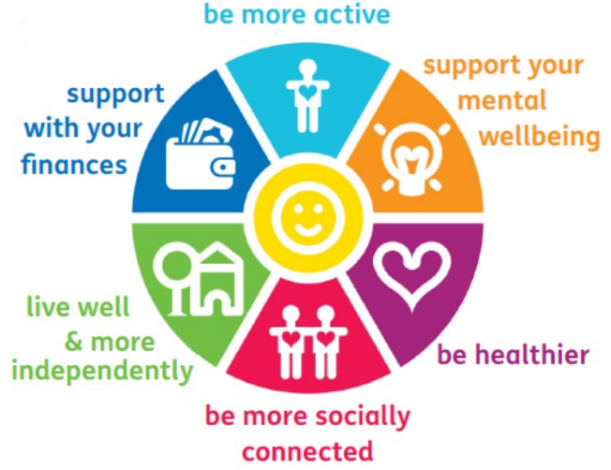

The social prescribers run a wide range of clubs and groups across Newcastle, including:
- Mindfulness sessions
- Arts and craft groups
- Gardening and allotments
- Table tennis
- Healthy eating
- Community mental health hub
They can also help you with issues relating to benefits claims, finances, social, lifestyle, housing and mobility.
If you think you would benefit from the Social Prescribers, you don't need to see a GP, just ask our reception team who would be happy to refer you!

Health and Wellbeing

5 Ways of Well-being
Connect – with family, friends, colleagues and neighbours. Invest time in building relationships.

Be active – Walk, run, dance, play. Discover physical activity you enjoy.
Take notice – catch sight of the beautiful. Savour the moment. Be aware of the world around you. Reflect.

Keep learning – try something new. Rediscover an old interest. Learn – how to cook, an instrument… Learning builds confidence.

Give – …A smile. Do something nice for a friend. Thank someone. Volunteer your time.
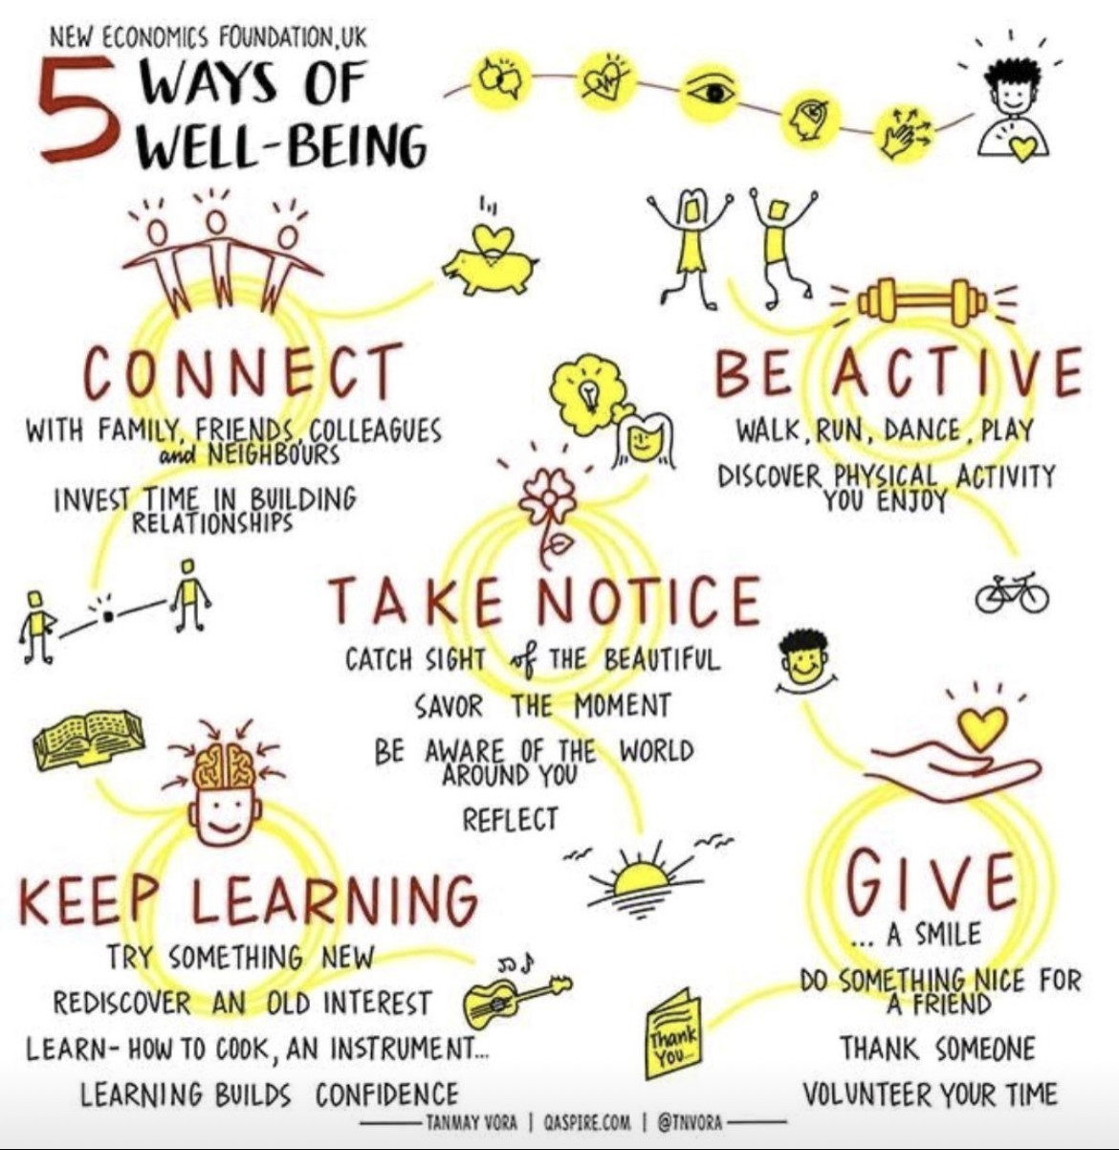

Need urgent help now?
Adults – call 0800 652 2863 for the CNTW crisis and home treatment team
Children and young people – call 0800 652 2864, CNTW children and young persons crisis team
Text number for people who are Deaf and/or have communication difficulties – 07919 228 548
The Newcastle Crisis Team are available 24 hours a day if you feel in mental health crisis on 0191 8148899.
Local Mental Health Services
Healthworks have produced a wide range of self-help leaflets, available in easy-read formats also, from dealing with alcohol and anxiety to self-harm and sleeping problems. The guides are meant as an introduction to self-help techniques, and you may find that you need to seek additional support from a health professional.
The Wellbeing Hub (previously known as vClub) is an excellent source of information and guidance on a very wide range of mental health and wellbeing related topics. With access to monthly newsletters, insightful articles and short videos, there are lots of ideas on ways to improve your day-to-day wellbeing.
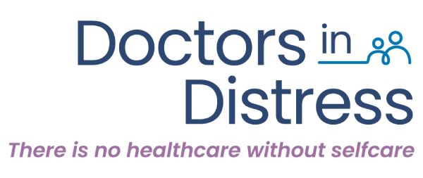

- Practitioner Health is a free, confidential NHS primary care mental health and addiction service with expertise in treating health and care professionals. They support the charity, Doctors in Distress.
Shiny Mind have launched a free version of their app for Nurses, Midwives and Healthcare Support Workers. They are working on their doctor/medical practitioner version and will roll this out in the future.
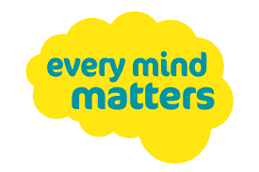

Every Mind Matters is full of tips for looking after your mental wellbeing.
Free online support and counselling are available at Kooth (11-18 year olds – but existing users can choose to stay until 25).
Free psychological therapy and counselling is available from Vita Health at VITA or call 03300534230. You can refer yourself by following this link: VITA Self Referral
Tyneside and Northumberland Mind – telephone 0330 174 3174 (charged at local rate). The Support Line hours are 7 days per week operating between 08.00am and 10.00pm and available to anyone aged 16 or over living in Newcastle or Gateshead.
Togetherall is a free, anonymous online mental health community where you can safely voice your feelings and connect with others. Moderated by professionals for your safety.
Visit 111 Online or call NHS 111 – open 24 hours a day, 365 days a year for any non-emergency medical problems
The Good Grief Trust website provides immediate bereavement support, helplines, information and advice.
Sign Post Nenc is a community hub of mental health and wellbeing services and resources.
Andy's Man Club is a peer support group for men with meet-ups in Gateshead and Newcastle.
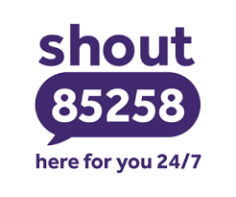
Text Shout on 85258 to use a free, confidential, 24/7 text messaging support service.
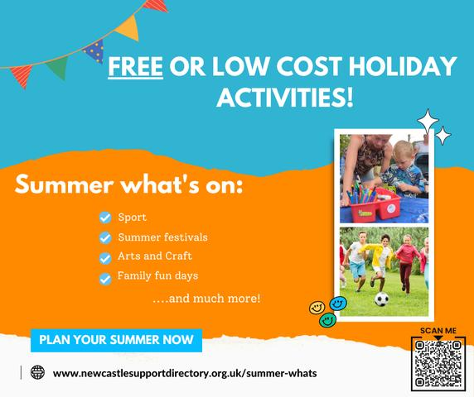
www.newcastlesupportdirectory.org.uk/summer-whats

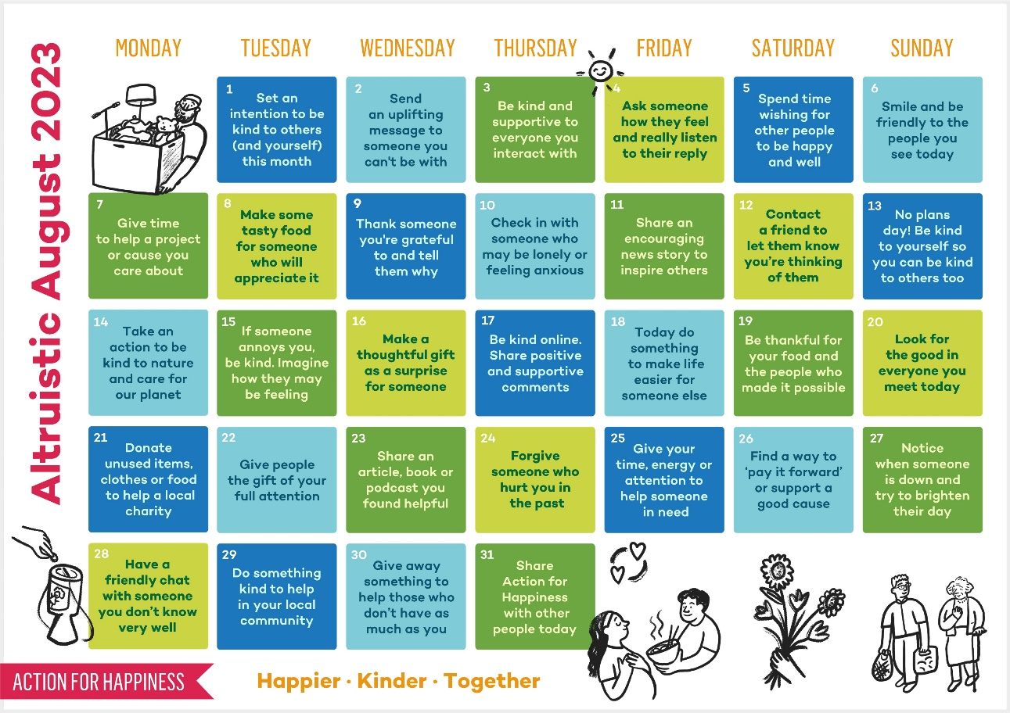

Join our Virtual Patient Participation Group (VPPG)
We have a very active Patient Participation Group (PPG) which meets once a quarter to discuss issues affecting patients and the practice.
We would like to invite a diverse range of people to join the PPG or register as a member of our Virtual Patient Participation Group (VPPG).

As a member of the VPPG, you would give us permission to contact you via e-mail to get your thoughts and feedback regarding issues raised at the PPG meetings. You would also be welcome to suggest things yourself to be discussed at the PPG meetings.
If you would like to become a member of the VPPG, please complete this form and return to us:

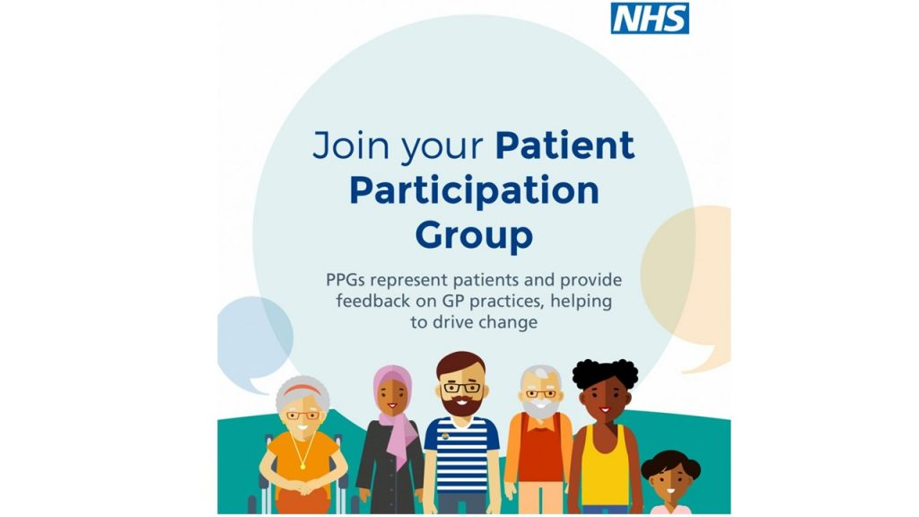

(Image text: Join your Patient Participation Group. PPGs represent patients and provide feedback on GP practices, helping to drive change.)

